What does a Bilateral Filter do!

Bilateral filtering does what is called robust estimation. This is compared to that of the method of least squares.

Least square methods:

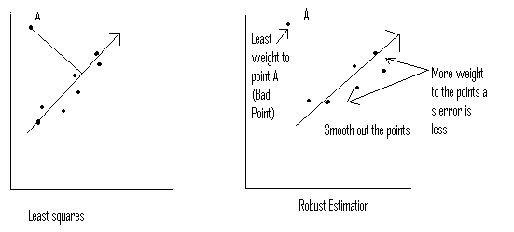

Consider a set of points as shown in the above figure and let us assume that the points are estimates of a straight line. Consider one point A as shown above which is vry far away from the rest. The least square methods sometimes fails in such situations and the final line estimate may be too much different from the one that is anticipated. However consider the case with robust estimation. In robust estimation the point that is far away form the rest is given less weight as the error( here distance from the rest of the points n the neighbourhood) is less . More weight is given to the points that are close to each other. The robust estimator thus takes such points far off as noise and leaves them! At the same time smoothes out the other points . The result being that we get the required smoothening and the effect of points like A is also nullified as it is treated as noise.

A real world example.

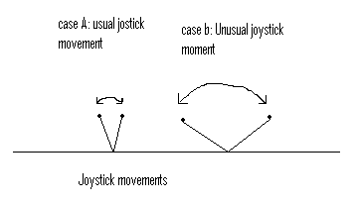
Consider a game joystick. One kinds of moments involve a usual less dynamic moments of the controller. A second case involves the abrupt moments . In the initial case the controller ,if it finds such moments smoothes out the moments to come to a final conclusion. However in latter case the controller might consider the abrupt moments as noise and just leave them out without smoothening .The error performance is as given below.. At infinity the error is clamped in case of bilateral filters (Robust estimators) while in least squares it grows.

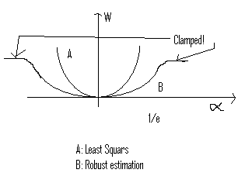

Bilateral filters act as “edge preserving smooth filters.”This can be easily explained as below.

Consider a drop of ink on a paper where diffusion phenomenon is seen. The ink “Spreads” to a certain distance. Now consider an image as a series of 2-dimensional drops of ink. The resulting image is obtained by diffusion of the ink by the 2-dimensional array of drops. However in bilateral filtering the diffusion across the edges is stopped. Which means that if we have an area say a green base and a white wall, the green tone DOES not diffuse into the white wall. The boundaries are left as is and hence this preserves the edges.

Bilateral filtering takes a lot of computational time which is slightly a drawback.
However with todays computational speeds bilateral filtering has been successfully been applied to meet the requirements.

WHATS NEXT! Trilateral filtering????

A similar filtering method can be trilateral filtering. Where the third dimension MAY be time. Here we might be needing to smooth a video.

- Canon has a DIGIC processor. For computations which involves converting the captured image into some formats like the JPGEG raw and so on.
- Cameras for Astronomy:
  - These cameras need to be able to have a very high quantum efficiency. Ex.: the ability to distinguish 1002 photons from 1000 photons. The quantum efficency is given as : QE=(output current)/photons
  - They need efficient sensors to distinguish noise from images like from stars.
  - It is easy to get photons in green which our eye is very sensitive to.

- Long Exposure Photography: In this photography we open the shutter for a more time . Usually useful at nights.

- Infrared Photography: (800 nm) Uses infrared light for photography. Ex. Coke snaps. We can actually take snaps using infrared light that can pass through coke .

- There are two kinds of photography

  - Active: where we hit an object with a beam and capture the image.
  - Passive: where the object has natural illumination or source.
When we have a source of light hitting glass, only some wavelengths pass through and others don’t.

THERMAL cameras:
Cameral which use temperature as a major factor in taking snaps. Heat rays at about 10000nm are directional.Here the heat radaiated by the source can be captured. For ex: the footprints leave their own signature of heat. Looking at them once can get a snapshot of the person walkin!!!!

QUESTION: how can ne build a camera that behaves as a thermal camera???

Noise In Sensors:

Slide 1:goes here
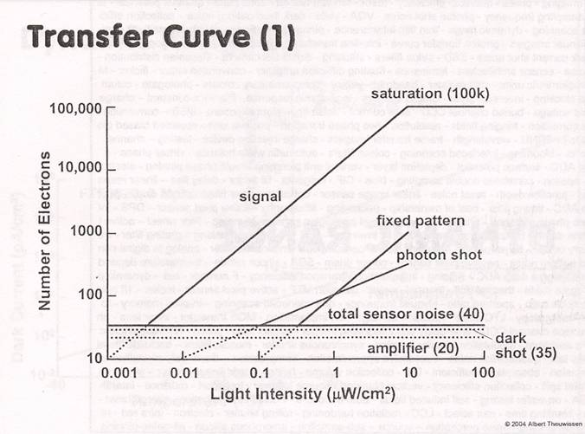

As more lights hits in more electrons are emitted. Hence the camera curve is close to linear. However noise starts kickin into the picture. Dark shot noise is present even when the shutter is closed. At higher values the Fixed Pattern noise kicks off more. This noise is also called the FPN.

This is the one that industries concentrate on and the answer to the question as to Why digital cameras have manual shutters is because of FPN.

Fixed pattern noise depends on various factors like the environment ,sensors used, on the person taking the picture

FOCUS(Slides 7 through 10)

The second assignment deals with the depth of focus. Here multiple images at “varying” depths of focus is taken and then all are combined into one picture which has a higher depth of focus. An example is seen in the slide animations.

Question: How is change Focus related to magnification. ??
There is a change in magnification when one changes the focus but the some cameras have come up with techniques such that the co-ordinates of the points are maintained .

Slides 11 through 13
Pin-hole camera and how does it capture image.A pin-hole camera forms an inverted ,less blurred image of the object in the image plane .Once this is done what we usually see is a 2 dimensional projectional of a 3 dimensional space. (Dimensionalty reduction)

Slide 14 through 18

These deal with the effects of projecting a 3-d space to a 2-d space.
- Railway tracks meet at infinity.
- Parallel lines arnt parallel.
- 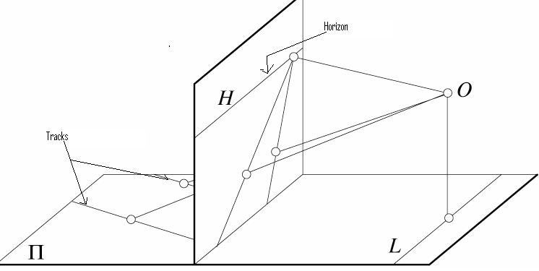

Slide 19 through 25
- Pin hole cameras
- We see that as the aperture gets smaller and smaller we tend to see diffraction patterns. The performance is better for a .35mm aperture hole. With apertures of size .07mm which can be compared to the wavelength of light, we see the diffraction patterns.

Slide 27 and 28
- Objects out of focus form a circle of confusion as shown in slide 28.

Slide 30 through 33
- Depth of field. Field upto which obects can be perceived as “being in foucus”
- Aperture controls the depth of field.
- Pictures with small focus have a nice perception .

Slide 35 through 40
- The slides deal with FIELD OF VISION:
- Field of vison is also the zoom. Max zoom implies less field of vision and vice versa.
Slide 41 through 45
- Comparisions between perspective and viewpoints
- Zoom lens actually provide a wide angle.

Slide 46 through 47 (Elliptical distortion)
- Reason for elliptical distortion
- All degree 2 curves are sections of a cone.
- If we cut a conic what we get is an ellipse and this explains the fact that why distortions are elliptical. N other words say we have a golfball and we want to PROJECT it onto a inclined plane. What we actually see in this case is an ellipse and NOT a sphere!!!

Assignment 2 preparation:

Take 5 images with varying focus and varying aperture. Combine all of them to get a composite image.

